MVC Pattern

Asp.Net MVC architecture separates an application into three main parts Model-View-Controller (MVC). MVC architecture provide good “separation of concerns” in general “Loose coupling”.

Following image show how asp.net mvc architecture flow will be

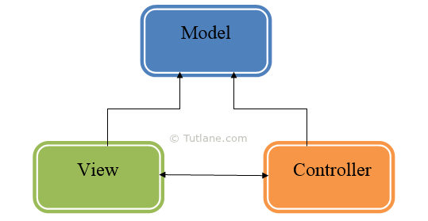

MVC splits application in to three parts
- Model
- View
- Controller

The Model
- The Model represent business logic and data.
- Often model is used for retrieve data and store data from a database.

The View
- The View is responsible displaying data and transforming Model or Models to visual representation.
- Most often the views are created from the model data.

The Controller
- Controller is a heart of the entire MVC architecture.
- The Controller as name tell it controls the application logic and interacts between model and view.
- The Controller take inputs from view and work with model and returns view.

ASP.NET MVC Page Life Cycle

